**PROJECT DESIGN PHASE - II**

**TECHNOLOGY STACK( ARCHITECTURE & STACK)**

|  |  |
| --- | --- |
| Date | **15 October 2022** |
| Team ID | **PNT2022TMID49884** |
| Project Name | **Personal Assistance for Seniors Who Are Self-Reliant** |
| Maximum Marks | **4 Marks** |

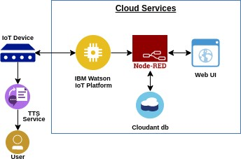**Technical Architecture :**

**Table-1: Components & Technologies:**

|  |  |  |  |
| --- | --- | --- | --- |
| **S.No** | **Component** | **Description** | **Technology** |
| **1.**  **2.** | User Interface | Mobile App | **HTML, CSS,**  **JavaScript**  **Python** |
| Application Logic-1 | Mobile App to enter the Medicine  Details weekly |
| **3.** | Application Logic-2 | Gets the medication data from database | **IBM Watson IoT API**  **Call data** |
| **4.** | Application Logic-3 | Converts the text to speech to pronunciation for the user | **IBM Watson**  **Assistant** |
| **5.** | Database | Medication time and tablets name on daily and | **MySQL** |
| **6.** | Cloud Database | Call the data IBM Cloudant is used and user login credentials | **IBM DB2, IBM**  **Cloudant** |
| **7.** | File Storage | App code and IoT credentials are stored and API keys | **IBM Block Storage** |
| **8.** | External API-1 | To get the medicine box status  Open or not | **IBM box status API** |
| **9.** | External API-2 | To get the login credentials in IBM  DB2 | **Username and**  **Password API** |
| **10.** | Machine Learning  Model | To convert the text into speech for voice command the tablet  details | **Text to speech** |
| **11.** | **Infrastructure**  **(Server / Cloud)** | **To host the server and application** | **Cloud Foundry,**  **Node Red** |

**Table-2: Application Characteristics:**

|  |  |  |  |
| --- | --- | --- | --- |
| **S.N** **o** | **Characteristics** | **Description** | **Technology** |
| **1.** | Open-Source  Frameworks | To develop the application interface, we use  **MITApp Inventor** | **MIT APP**  **INVENTOR** |
| **2.** | Security  Implementations | To secure the users login credentials and personal information | **SHA-256, OWASP** |
| **3.** | Scalable Architecture | To scale the application database | **IBM Auto scaling** |
| **4.** | Availability | To make use the application and data are available 24/7 | **IBM Cloud load balancer** |
| **5.** | **Performance** | **To increase the performance the** **application in hosted in the high- performance instance** | **IBM instance** |